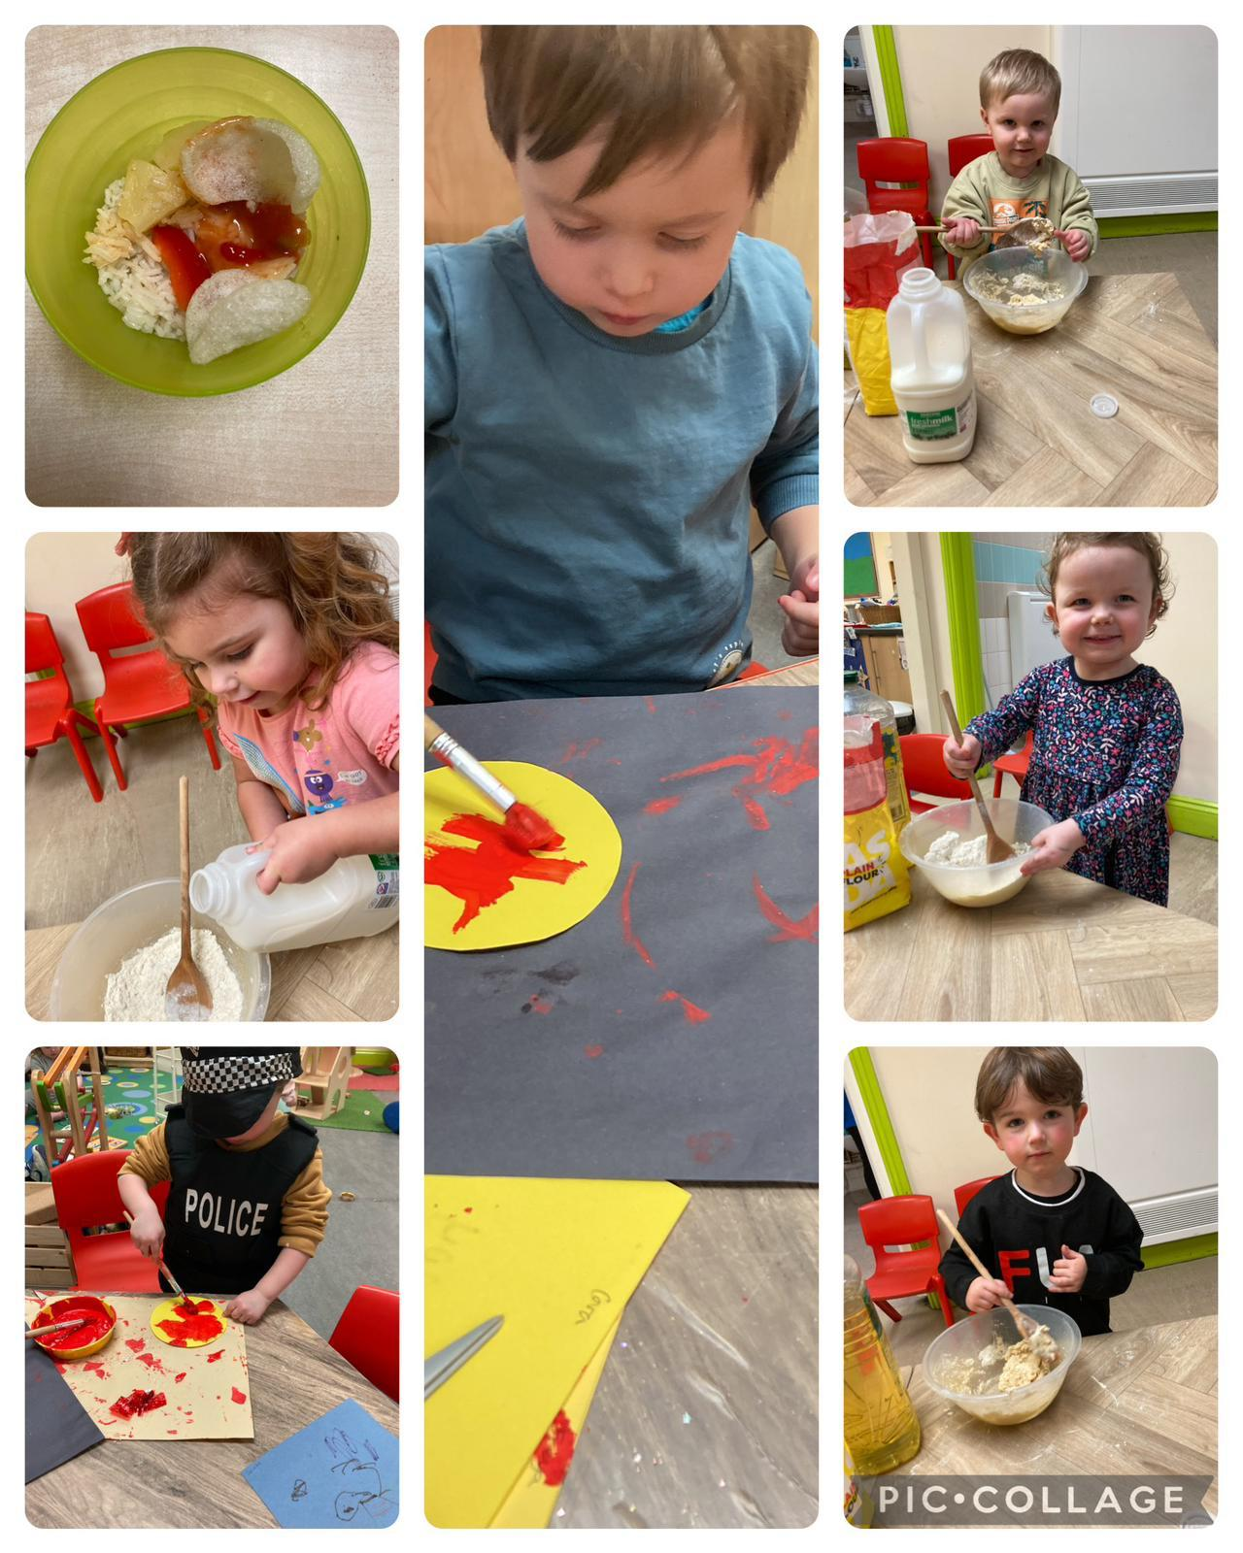

Flying Start/Little Gems have had a busy week.

They had some Chinese food to taste, helped make pancakes, painted some pictures, played with bubbles and had some fun outside.

